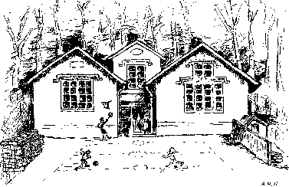
Christ Church C of E (VA) Primary School
Old Neighbourhood
Chalford
Stroud
Glos
Our Journey – love, live, laugh, learn.

GL6 8PP
01453 882138
admin@christchurch-chal.gloucs.sch.uk
www.christchurch-chal.gloucs.sch.uk
Executive Head Teacher: Mrs Rebecca Slater
8th September 2020

Clubs – Autumn Term 2020

Dear Parents,

Please fill in the attached permission slips and return to school by Friday 11th September to register your interest for clubs. Please note if there is not enough interest for a particular club it may need to be cancelled. To assist working parents, we will now be running each club throughout the term.

All clubs will run between 3:00pm and 4:00pm

DAY | CLUB | AGE RANGE | START DATE | FINISH DATE | Member of Staff
Tuesdays | Drama Club | All year groups | Tue 15th Sep | Tue 15th Dec | Superstars
Wednesdays | PE Club | All year groups | Wed 16th Sep | Wed 16th Dec | Atlas Sports
Thursdays | Craft Club | All year groups | Thu 17th Sep | Thu 10th Dec | Mrs Smith

Kind Regards,
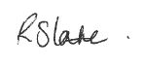
Rebecca Slater
Executive Head Teacher
Drama Club
I give permission for ________________________________ (name of child) to attend Drama Club on Tuesdays from 15th September to 15th December from 3:00 to 4:00pm
Signed ______________________________________ (Parent/Carer)
Please return to school office by Friday 11th September

................................................................................................................................................................

PE Club
I give permission for ________________________________ (name of child) to attend PE Club on Wednesdays from 16th September to 16th December from 3:00 to 4:00pm
Signed ______________________________________ (Parent/Carer)
Please return to school office by Friday 11th September

................................................................................................................................................................

Craft Club
I give permission for ________________________________ (name of child) to attend Craft Club on Thursdays from 17th September to 10th December from 3:00 to 4:00pm
Signed ______________________________________ (Parent/Carer)
Please return to school office by Friday 11th September

